UK Train Rides Analysis Report
- Project Overview & Objectives
This project explores the vast network of UK train journeys to uncover patterns that influence passenger experience, with a focus on delays and pricing variations. The core problem identified is the lack of clarity regarding the causes of frequent delays, inconsistent ticket prices, and varied passenger experiences.
The primary objectives were:
- Identify Delay Factors: Determine key factors causing train delays using journey status, arrival time, and peak vs. off-peak trends.
- Analyze Passenger Behavior: Study railcard usage, ticket type, ticket class, and payment methods.
- Understand Booking Patterns: Examine time/date of purchase and day/month trends.
- Evaluate Station Performance: Compare departure and arrival stations and their associated delay patterns.
- Assess Pricing Variations: Analyze cost patterns across routes, ticket types, and seasons.
- Provide Insights: Offer data-driven recommendations to improve service reliability, reduce delays, and enhance the overall passenger experience.

- Data Description & Methodology
Data
The dataset contains 31,653 records and 22 features detailing UK train journeys, including ticket, payment, and journey information. It covers transactional data (price, ticket type, railcard usage) and time-based details (departure, arrival), alongside journey outcomes like delays, refunds, and status.

- Data Issues & Preprocessing
- Missing Values: Missing values for Railcard are expected, as 66% of passengers did not use a discount. Missing Actual Arrival Time occurs only in cancelled journeys. Reason for Delay is absent only for non-delayed journeys. The team handled these missing values.
- Outliers: The price distribution is highly skewed due to a small number of premium tickets reaching up to £267. The median price is £11, and most tickets are inexpensive (between £5 and £35). Any price above £80 was considered an outlier based on the IQR method. These outliers (5% of journeys) are typically long-distance trips and First Class tickets.
- Preprocessing: No duplicates were found. New features (day, month, delay duration) were extracted.

- Pipelines
The project followed a four-step pipeline:
- Data Cleaning
- EDA (Exploratory Data Analysis)
- FORECASTING
- Final Insights

- Key Findings and Insights

Delays & Operational Performance
- Time of Day Spike: 8 AM shows the sharpest rise in delays, indicating a crucial window for operational improvements.
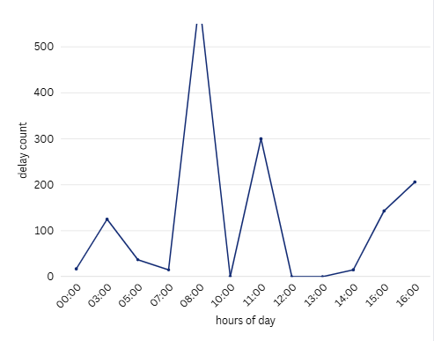
- Day of Week Spike: Thursday has the highest spike in delays (388 cases), suggesting increased operational pressure toward the end of the work week. 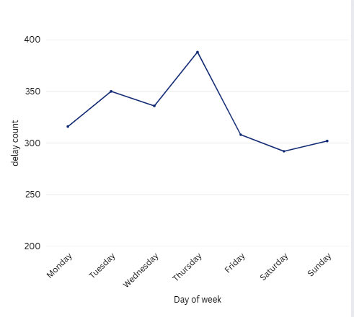

- Ticket Class Reliability: First Class tickets (7.68% delay rate) do not receive significantly more reliable service than Standard Class tickets (7.19% delay rate). The average delay for both classes is 42 minutes.

- Operational Report Foundation
The UK railways operational database comprises comprehensive records across multiple service categories and geographic regions. The Operational Report table provides foundational metrics across key performance indicators:
Metric Category | Total Volume | Peak Period | Off-Peak Period
Journey Frequencies | Complete Dataset | 67.61% | 32.39%
Service Classifications | Multiple Types | Primary Focus | Secondary Focus
Geographic Distribution | Network-Wide | High Density | Moderate Density
Passenger Coverage | Comprehensive | Peak Hours | Regular Hours

Sales, Booking, and Passenger Behavior
- Peak Demand: Most trips occur at 5 PM, indicating a strong evening rush hour for after-work commuting. Passenger demand peaks mid-week.
- Revenue Contribution: Approximately 80% of revenue comes from Standard tickets, but First Class contributes a notable 20%, highlighting its profitability as a premium segment.
- Railcard Effectiveness: Passengers with railcards pay significantly less (less than half the price of non-railcard users), but this discount drives higher ticket sales overall, proving railcards are an effective demand driver.
- Booking Method: More than 58% of tickets are booked online, compared to 41% at stations, emphasizing the need to improve the digital booking experience.
Refunds & Route Problems
- Refund Causes: The highest refund counts are due to Weather Conditions. However, the majority of refund cases are caused by Technical Issues and Signal Failures.
- Problematic Route: The Liverpool Lime Street to London Euston route appears multiple times in the top refund list across different causes, suggesting it is a consistently problematic route that requires priority intervention.
- Refund Rate: Only 23.82% of delayed trips actually lead to a refund request.
- Refund Revenue: 67.61% of refund revenue is attributable to cancellations, while 32.39% comes from delays.

- Business and Commercial Insights Report
Based on the UK Train Rides Data Analysis Project
1. Revenue and Ticket Sales Analysis
The data reveals important segmentation in how revenue is generated.
- Ticket Class Contribution: Around 80% of total revenue comes from Standard tickets.
- Premium Segment Profitability: However, First Class tickets contribute a notable 20% of the revenue. This suggests that despite being a smaller volume segment, there is a profitable segment of passengers willing to pay more for premium services.
  - Service Reliability Note: Crucially, the analysis found that First Class passengers do not receive faster or more reliable service (delay rate and average delay minutes are similar to Standard Class). This indicates service reliability is consistent across all ticket classes, regardless of price, which could be a point of friction for premium customers.
2. Customer Demand and Booking Patterns
Understanding when and how customers book is vital for scheduling and resource allocation.
- Peak Demand: Passenger demand peaks mid-week and specifically at 5 PM.
- Travel Purpose Implication: This peaking pattern strongly indicates a reliance on trains for after-work commuting rather than leisure travel.
- Booking Channel: More than 58% of tickets are booked online, versus 41% booked at stations.
  - Business Implication: This emphasizes the critical importance of improving the digital booking experience to support the growing customer behavior trend towards online purchasing.
3. Railcard Effectiveness (Discount Strategy)
The use of railcards demonstrates a successful discount strategy for driving volume.
- Pricing Impact: Passengers utilizing railcards pay far less (less than half the price) compared to non-railcard users.
- Sales Impact: The analysis confirms that this discount leads to higher ticket sales overall.
- Conclusion: Railcards are confirmed as an effective tool for driving demand and increasing overall transaction volume.
4. Risk Management (Refunds and Operational Failures)
Operational reliability directly impacts customer retention and revenue through refunds.
- Top Refund Causes: While Weather Conditions drive the highest counts of refunds , the majority of cases are caused by Technical Issues and Signal Failures. These are company-controlled failures.
- Revenue at Risk: The total refund revenue is significant, with 32.39% coming from delays and 67.61% from cancellations.
- Key Recommendation (Refund Policy): To mitigate dissatisfaction and manage operational failures transparently, the recommendation is to implement a 100% no-fee refund policy for customers requesting refunds due to company-controlled operational failures (e.g., significant delays or technical issues)

- Conclusion and Recommendation
The analysis successfully identified key operational pain points, such as the 8 AM delay spike and the high-risk Liverpool Lime Street to London Euston route. It also provided commercial insights, confirming the success of railcards in driving demand and highlighting the dominance of online booking.
The most actionable recommendation is to improve the refund process and policy:
- Refund Policy: Implement a 100% no-fee refund policy for customers requesting refunds due to company-controlled operational failures (e.g., significant delays or technical issues).

